Multiple-choice section – choose the correct answer

Question 1 [4.6] [10A]

When using the quadratic formula to solve x2 – 2x + 4 = 0, the values of a, b, c are, respectively:

A 1, -2, -4 B 1, -2, 4 C 3, -1, 4 D 4, -2, 1

Question 2 [4.5] [10A]

The factors of 7x2 + 20x – 32 are:

A (7x – 3)(x + 5) B 3(7x − 4)(x + 8) C (2x + 7)(3x – 4) D (7x – 8)(x + 4)

Question 3 [4.6] [10A]

Which equation has solutions 5 and -0.5?

A (x – 5)(2x + 1) = 0 B (x + 5)(x – 0.5) = 0

C (2x – 1)(x – 5) = 0 D (2x – 5)(x + 0.5) = 0

Question 4 [4.6] [10A]

The quickest way to solve (x – 7)(x + 1) = 0 is by:

A completing the square B using the quadratic formula

C using the null factor law D multiplying the two numbers

Question 5 [4.2]

Completing the square to factorise x2 + 6x + 2 will give:

**A** (x + 3 + )(x + 3 – ) **B** (x + 3 + )(x – 3 – )

**C** (x + 3 + 7)(x + 3 – 7) **D** (x + 3 + )(x + 3 – )

Question 6 [4.4]

The values of h and k in the expression  are respectively:

**A** 5 and 9 **B** 5 and -2  **C** 9 and 5  **D** -9 and 3

Question 7 [4.3]

The solutions to x2 + 4x + 1 = 0 are:

A  B - C  D 

Question 8 [4.4]

The turning point (x, y) of the graph of y = (x + 2)2 – 6 is:

**A** (2, 6) **B** (2, -6) **C** (-2, 6) **D** (-2, -6)

Multiple-choice results: ___ / 8

Short answer section

Question 9 9 marks [4.1, 4.3]

Solve these equations using the null factor law.

**(a)** x(x – 7) = 0

**(b)** (x + 4)(x – 2) = 0

**(c)** 64 – 49x2 = 0

**(d)** By completing the square and using the difference of two squares, solve the equation  
 x2 + 5x + 5 = 0.

Question 10 4 marks [4.2]

**(a)** Factorise x2 – 11x + 24.

**(b)** Use the null factor law to solve the equation x2 + 24 = 11x.

Question 11 6 marks [4.2, 4.3, 4.4]

**(a)** Write y = x2 + 12x + 3 in turning point form.

**(b)** Find the turning point of the graphs with equation y = x2 + 12x + 3.

Question 12 6 marks [4.1]

The area of a rectangle can be expressed as (x2 + 5x – 24) cm2.

**(a)** Factorise x2 + 5x – 24.

**(b)** What are the possible values of x if one of the dimensions of the rectangle is 13 cm?

**(c)** What are the possible values for the area?

Question 13 6 marks [4.2, 4.3, 4.4]

For the parabola y = x2 + 6x + 2:

**(a)** Express the equation in the form: y = (x − h)2 + k by completing the square.

**(b)** State the coordinates of the turning point.

**(c)** Find the coordinates of the x-intercepts as exact values.

Question 14 4 marks [4.6] [10A]

Use the quadratic formula to determine whether the following equations can be solved for x. You need to give reasons for your answers, but you do not need to solve the equations.

**(a)** x2 + 2x + 8 = 0

**(b)** 3x2 – 5x – 12 = 0

Question 15 3 marks [4.2]

Factorise  by completing the square.

Question 16 4 marks [4.6] [10A]

The concrete area of a rectangular outdoor area is 36 m2. If the length is (2x + 3) m  
and the width is (x + 1) m, find the dimensions of the concrete area.

Question 17 6 marks [4.4]

Find the x- and y-intercepts of the graphs with the following equations.

**(a)** y = x2 – 3x – 18

**(b)** y = x2 – 16

Question 18 3 marks [4.4]

Sketch the graph of y = (x – 1)2 + 4 showing all relevant points.

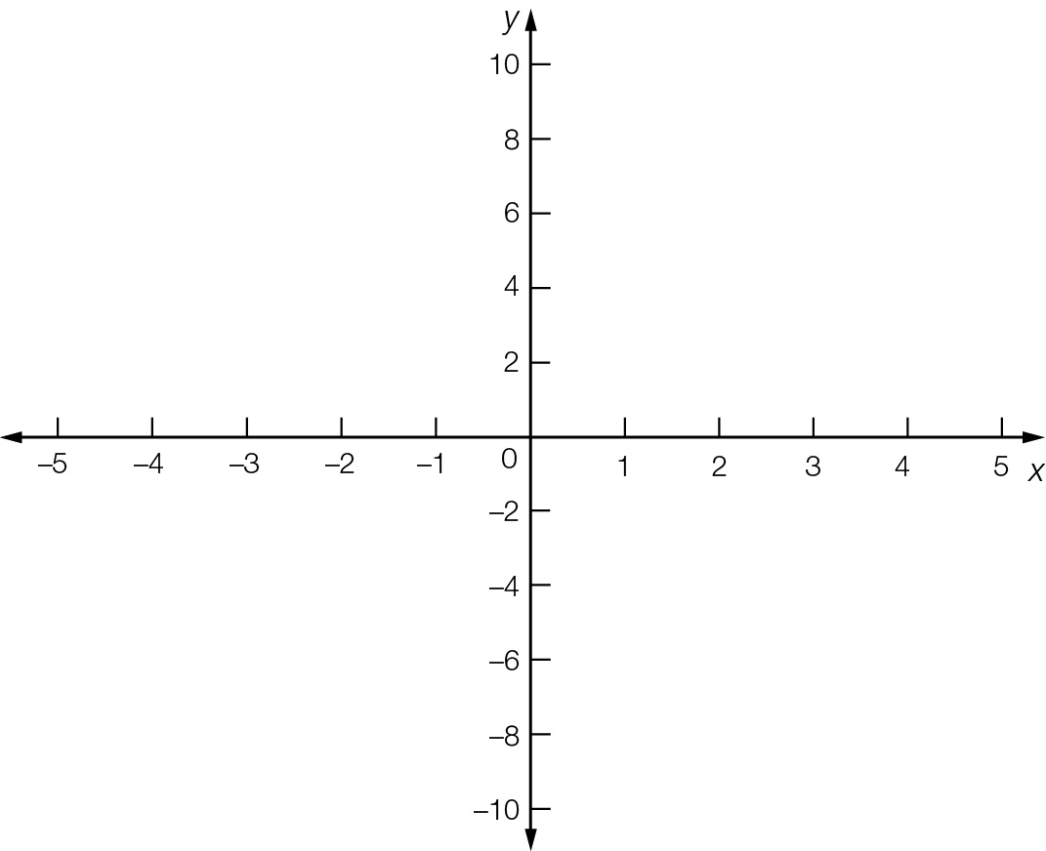

Question 19 3 marks [4.4]

The turning point for the graph with the equation y = a(x – h)2 + k is (8, 3) and y = -2 for x = 7. Calculate the values of a, h and k.

Short answer results: ___ / 54

Extended answer section

Question 20 6 marks [4.4]

A rocket launcher, which can be programmed to follow a variety of paths, is placed in a hole in the ground so that the missile appears to come out of the ground at zero height.

The launcher is initially set to follow the path h = -3(d – 30)2 + 1800, where h represents the height of the rocket in metres and d is the horizontal distance travelled in kilometres.

**(a)** Sketch the pathway of the missile on the number plane provided.

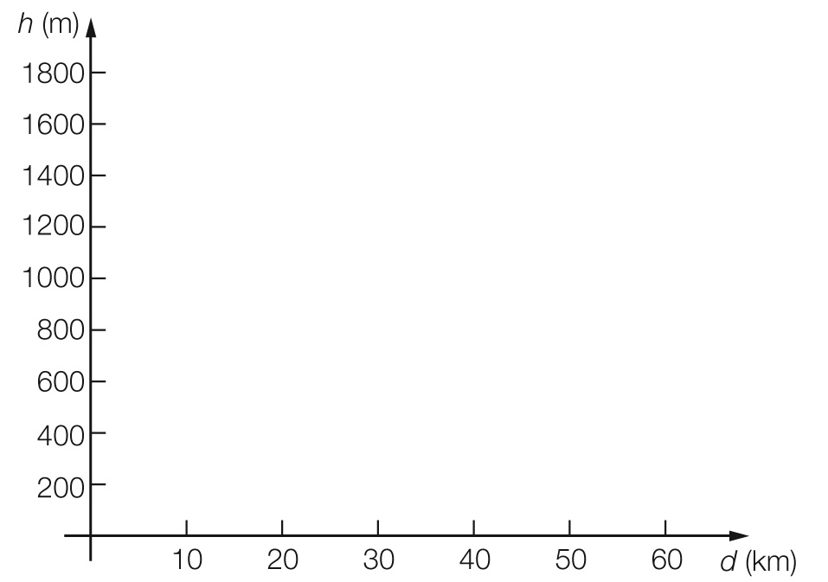

**(b)** State the maximum height reached by the missile.

**(c)** Find the distance between the launch site and target.

Question 21 6 marks [4.1]

A square of side length 4x cm contains a circle of radius 2R cm.

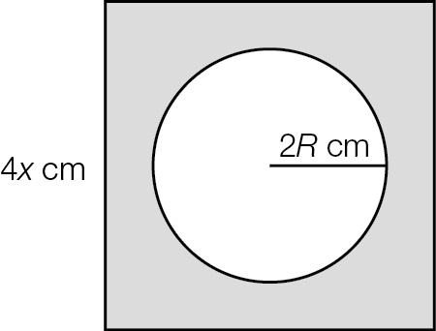

(a) Write an expression that gives the shaded area.

(b) Factorise the expression in part (a). Express your answer in exact form.

(c) (i) For what values of x is the expression zero?

(ii) Explain why these values are not realistic in terms of representing the shaded area.

Question 22 9 marks [4.2, 4.3, 4.4]

The equation y = 6x – x2 gives the height y metres of a projectile at time x seconds after it has left the ground.

(a) Complete this table for the values of x and y.

|  |  |  |  |  |  |  |  |
| --- | --- | --- | --- | --- | --- | --- | --- |
| x | 0 | 1 | 2 | 3 | 4 | 5 | 6 |
| y |  |  |  |  |  |  |  |

(b) Plot the points to show the path of the projectile on the grid provided.

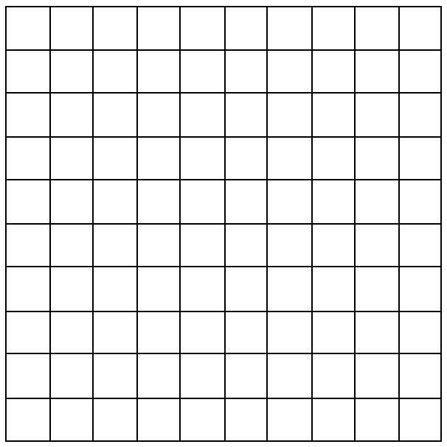

(c) State the turning point of the graph.

(d) Find the x- and y-intercepts of the graph.

(e) Complete the square to find, correct to 2 decimal places, the two times when the projectile reaches a height of 7 m.

(f) Explain why there are two values found in part (e).

(g) Explain why there are no solutions where y = 10.

Question 23 4 marks [4.4]

Chris can throw a tennis ball so that its path is given by the equation h = -x(x – 8).

What is the highest height that the tennis ball reaches?

Extended answer results: ___ / 25

TOTAL test results: ___ / 87